Record No: 0620

DOROTHEA VICTORIA SOMERVILLE

3rd daughter of Corry Somerville (0586) and Lucinda Simonton (0587).
Birth: 24 September 1840 Rochester, New York
Baptised March 1, 1844, St. Paul’s Episcopal Church, Rochester, New York
Marriage: 24 January 1870, Hugh Stevenson (0621) son of Robert Stevenson and
Elizabeth Connaghty Stevenson, in Cleveland, Ohio.
Death: 16 September 1922, Jericho, Bosanquet Twp, Lambton Co, Ontario
Buried Beechwood Cemetery, Forest, Ontario.
Notes:
In a letter written to his brother Tenison, in July 1867, Corry described his daughter Dorothea as “black hair, black eyes and skin of the same colour, considered very clever and very handsome. I will say very good - hard work to keep her from being taken away. [The height, black hair and dark eyes have been passed on through the generations, as her descendants are very tall, dark haired, although some have green eyes like Dorothea's husband, Hugh, who was a "stubborn red-headed Irishman"!]

Dorothea’s early education was either in Rochester, NY or Caistor Township, Ontario. She had probably met her future husband while the family was living in Caistor, as her sister, Eliza, had married Hugh Stevenson’s close friend, John Gamble. Dorothea moved with her parents to Buffalo, New York, area before settling in Cleveland, Ohio.

Dorothea didn`t marry Hugh Stevenson until she was 30, and after the family had migrated to Cleveland, in January 1870. Hugh had previously purchased a farm at Lot 11, Concession 8, Bosanquet Twp, Ontario on November 15, 1866, but he didn’t stay there for very long, as he had moved to Cleveland by January 1870, when he married Dorothea Somerville. Their first 3 children were born in Cleveland, Somerville Bellingham Stevenson, Thomas McIlroy, Stevenson, Rosay and her twin, Quayle, who died in infancy. By February 1880, the family had returned to the4 farm in Canada, where Robert Corry was born. The family continued to reside at ‘the home place’, where both Hugh and Dorothea died, and Robert Corry lived at the farm until just before his death. The home was originally a one story log building, which met the Settlement Duty of the original patent owners, but Hugh added a second storey and a back porch to accommodate his growing family. For part of the time, two of Dorothea’s nieces from her deceased sisters Henrietta (Mysie Street) and Lucinda (Ida MacKinnon) lived with the family at the farm.
Dorothea was known as Aunt Dolly to many. She raised her nieces Ida McKinnon (from sister Lucinda Kate), and Mysie Street (from sister Alicia) with her own children. She must have been a prolific writer, as we have copies of over 250 post cards in 2 year period. It was clearly important for her to keep in touch with her family, especially those in Cleveland, with whom she was particularly close.

Dorothea and Hugh continued to live in ‘the home farm’, after her son Robert Corry was married to Katherine and raising their own children there. Dorothea’s granddaughter, Florence Stevenson, had fond memories of her Grandmother Dorothea, as shown in this excerpt:

“My father, Robert Corry Stevenson, was the youngest child of Grampa Hugh and Grandma Dorothea Victoria. Grandma Dorothea was a very talented, artistic person. She played the violin, the grand piano, and loved to dance. She taught my father to dance and he was known in the community for his excellence. I, personally, would agree, since he was the best partner I ever danced with. The ballroom was on the second floor of the general store in the village of Thedford, between four and five miles from the farm. The story goes that my father would walk down the railroad track to the village and the same home. He had a full length Beaver coat which he wore – put his dancing shoes in the pockets, and off to the Ball. The story goes that Grandma never slept soundly until “Robbie was home. She had bricks warming in the oven to put in his bed when he arrived home and didn’t worry about time when he wakened in the morning.
Grandma, or “Aunt Doll” as she was known in the community, was reported to make the ‘best’ pickles on the 8th Concession.
My brother, Don, had blonde curly hair until he was about three years old. Father couldn’t abide that ‘his son’ had curls so he proceeded to cut his hair one afternoon. Grandma Dorothea lived with us on the farm. She was so indignant that the ‘baby’s’ curls were cut off that she packed her satchel and walked the half mile up to Aunt Rosie Catt’s, until she calmed down.”
The 1920 US census shows Grandma Dolly as visiting nephew Serle Dennis in Cleveland, where she had made the long journey, transferring trains, at the age of 80. She died at home on the farm just two years later.

Dorothea Had issue:
1 Somerville Bellingham Stevenson, b.20 July 1871, married, and had issue d.July 1918, Bozeman,
Montana, where he had been a teamster, and after a fight at a saloon, where he was defending a woman’s honour.
2 Thomas McIlroy Stevenson , b.27 November 1873, Cleveland, Ohio, married and had issue d. 1944
Arkona, Ontario. Uncle Tim, as he was known, was a telegraph operator, and spent many years living in New Mexico, before returning to Canada.
3 Rose Eliza, twin, b. 11 April 1875 Cleveland Ohio, married and had issue. After her marriage, Rosie lived just a couple of farms over from her parents.d.18 February 1954,Jericho..
4 Quayle Stevenson,twin, b. 11 April 1875 d.24 July 1875-cholera.Cleveland, Ohio
5 Robert Corry Stevenson, b.14 February 1880, Jericho, md. Katherine McLeod
17 March 1915 in Thedford, Lambton Co, Ontario and had 4 children: Florence (Lawrence Lindeman),
Margaret (Morley Gough), Donald Somerville Stevenson (Marjorie Bannister) – father of Wendy Stevenson’s husband, Robert (Bob) Stevenson,- and Robert Gordon Stevenson (Peggy Clay). Robert Corry Stevenson was a tax collector and farmer, and remained at the home farm until just before his death.

Source: Somerville Index and Wendy Stevenson.
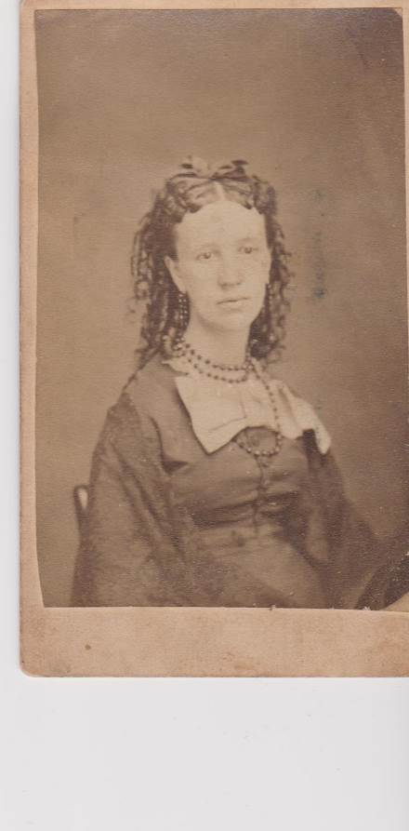
Dorothea Victoria Somerville. C 1869,
Probably at the time she married.

